**Foundation of algorithms**

**IE2072**

IT21831904

Weerasinghe K.M

Contents

Question 01 3

Output 5

Question 02 6

Output 8

# Question 01

#include <stdio.h>

int main() {

    int N, M; // Declare N and M.

    int k;

    // Prompt the user to input the matrix size

    printf("input the matrix size:\n");

    scanf("%d %d", &N, &M);

    // Declare a matrix array with N rows and M columns.

    int matrix[N][M];

    // user to input matrix elements.

    printf("input Matrix elements:\n");

    int i, j; // Declare loop counters .

    for (i = 0; i < N; i++) {

        for (j = 0; j < M; j++) {

            scanf("%d", &matrix[i][j]); //  matrix elements in the array.

        }

    }

    int X = 0, Row_Val, Col_Val; // Declare variables for X, Row_Val, and Col_Val.

    // Iterate while Row_Val or Col_Val is not equal to 1, or until a certain condition is met.

    for (k = 0; k < (N * M); k++) {

        for (i = 0; i < N; i++) {

            Row_Val = 1; // Initialize Row_Val to 1.

            for (j = 0; j < M; j++) {

                // Check if any element in the current row is less than X.

                if (X > matrix[i][j]) {

                    Row_Val = 0; // If yes, set Row_Val to 0 and break out of the loop.

                    break;

                }

            }

            if (j == M) // If j reaches M, it means all elements in the row were greater or equal to X.

                break;

        }

        for (i = 0; i < M; i++) {

            Col_Val = 1; // Initialize Col_Val to 1.

            for (j = 0; j < N; j++) {

                // Check if any element in the current column is less than X.

                if (X > matrix[j][i]) {

                    Col_Val = 0; // If yes, set Col_Val to 0 and break out of the loop.

                    break;

                }

            }

            if (j == N) // If j reaches N, it means all elements in the column were greater or equal to X.

                break;

        }

        //  increment X.

        if (Col_Val == 1 && Row_Val == 1)

            X++;

        // no, break the loop.

        else

            break;

    }

    int result = X - 1; // Calculate the result final X value.

    // Print the result

    printf("X value: %d\n", result);

    return 0;

}

# Output

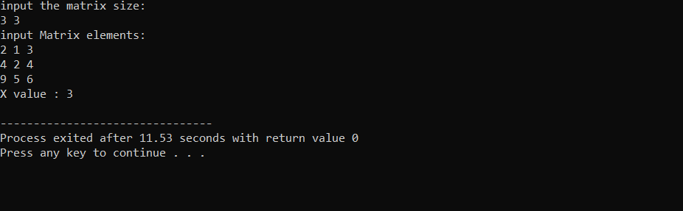

# Question 02

#include <stdio.h>

int main() {

    int N, K, count = 0,i;

    // User input for the size of the array frequency

    printf("Enter the size of the array frequency: ");

    scanf("%d", &N);

    int frequency[N]; // Declare the frequency array

    // User input for elements of the array frequency

    printf("Enter elements of the array frequency: ");

    for (i = 0; i < N; i++) {

        scanf("%d", &frequency[i]);

    }

    // User input for the size of the array Key_size

    printf("Enter the size of the array Key_size: ");

    scanf("%d", &K);

    int key_size[K], num_keys = 0; // Declare the key_size array

    // User input for elements of the array Key_size

    printf("Enter elements of the array Key_size: ");

    for (i = 0; i < K; i++) {

        scanf("%d", &key_size[i]);

        num_keys += key_size[i]; // Calculate total keys

    }

    if (num_keys < N) {

        printf("-1\n"); // Not enough keys for the frequency array

    } else {

        // Sort the frequency array in descending order

        for (i = 1; i < N; i++) {

            int current = frequency[i];

            int j = i - 1;

            while (j >= 0 && frequency[j] < current) {

                frequency[j + 1] = frequency[j];

                j--;

            }

            frequency[j + 1] = current;

        }

        printf("The array in descending order is:\n");

        for (i = 0; i < N; i++) {

            printf("%d ", frequency[i]);

        }

        int loop_count = 0;

        int j = 1;

        while (loop_count < N) {

            int i = 0;

            int available_keys = 0;

            // Count how many keys are available in the current loop

            for (i = 0; i < K && loop_count < N; i++) {

                if (key_size[i] > 0) {

                    available_keys++;

                    loop_count++;

                }

            }

            // Distribute available keys and calculate the cost

            for (i = 0; i < available_keys; i++) {

                key_size[i]--;

                count += (frequency[loop_count - available_keys + i] * j);

            }

            j++; // Increment j for the next iteration

        }

        printf("\nThe minimum cost is %d\n", count);

    }

    return 0;

}

# Output

